**Employment Experience**

**WISYNCO GROUP   
Brand Ambassador October 2017-Present**

* Increased brand awareness with target market by enthusiastically educating prospective customers about the suite of products offered by the company.
* Enhanced customer service by accurate and timely responses to customers queries and recommendations to supervisors based on high-level product knowledge.
* Delivered accurate Promotional Report documentation of daily activities such as opening and closing stock of featured products.

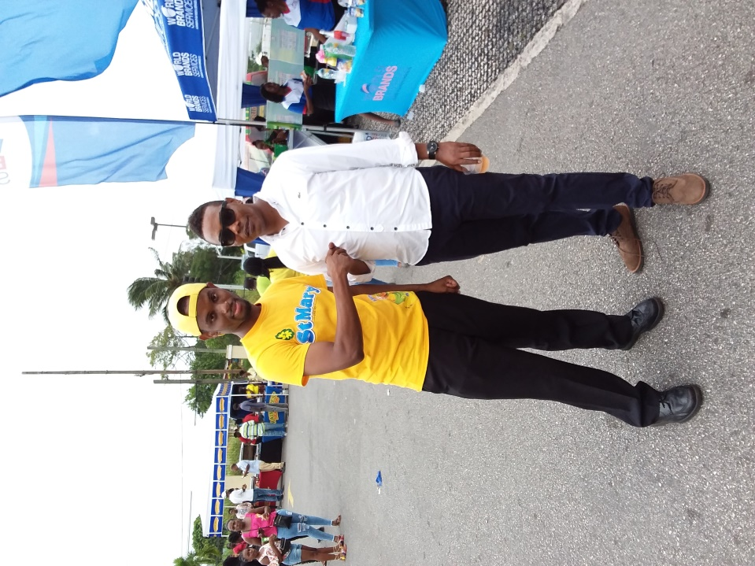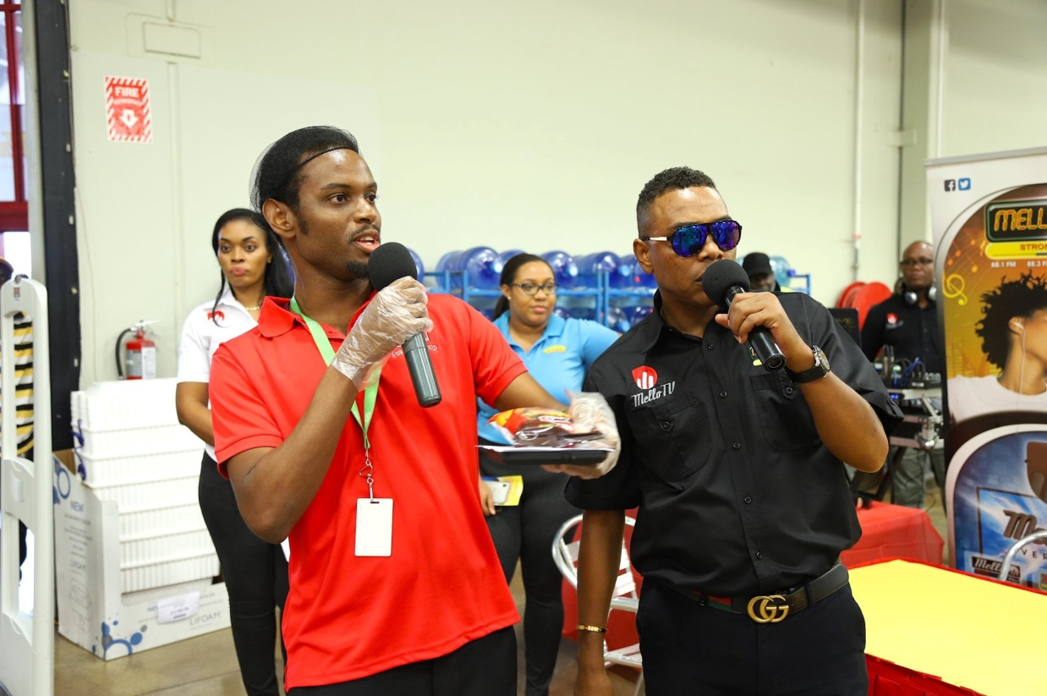

**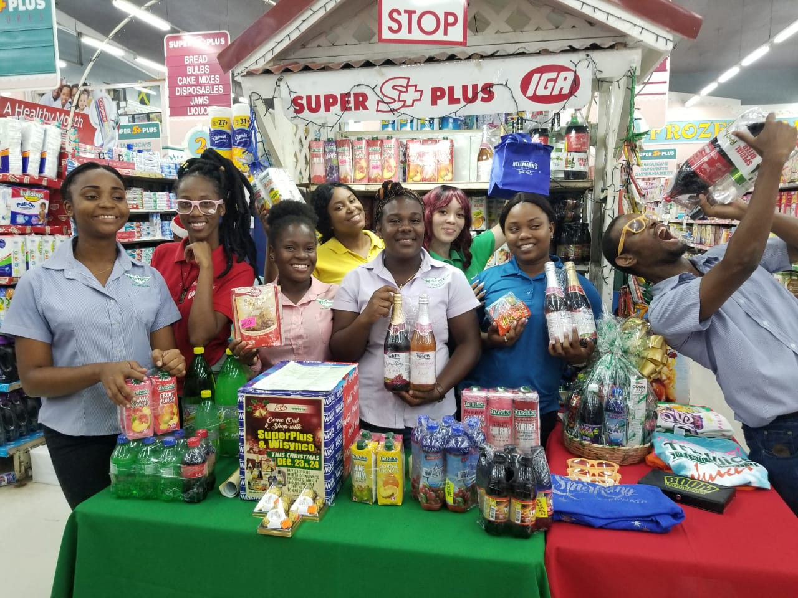  
UNICOMER JAMAICA (COURTS JAMAICA LTD)** **August - December 2016  
Collections/Call Centre Agent**

* Preserved good customer relations by tactfully reminding customers of their outstanding balances.
* 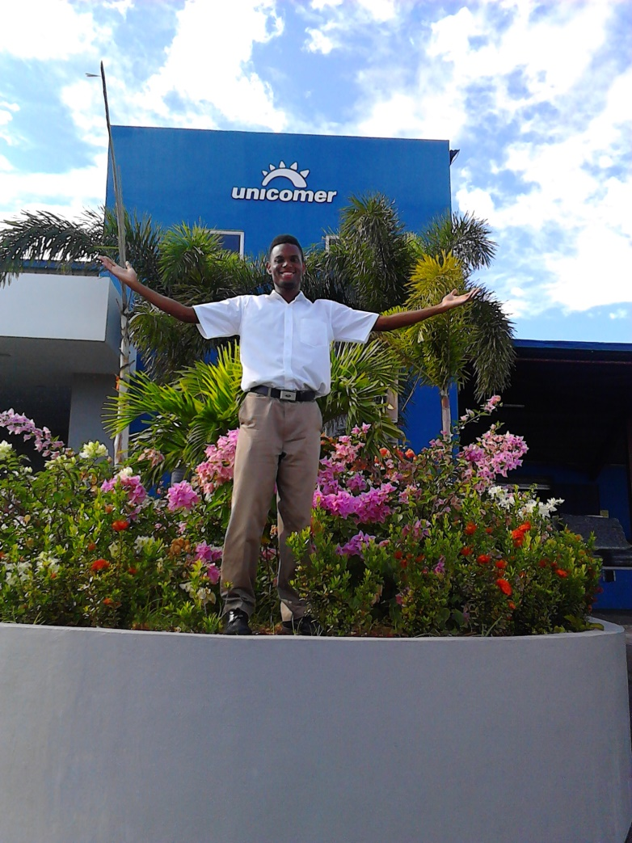Reduced accounts receivables up to $2M monthly by persuading customers to address their arrears.

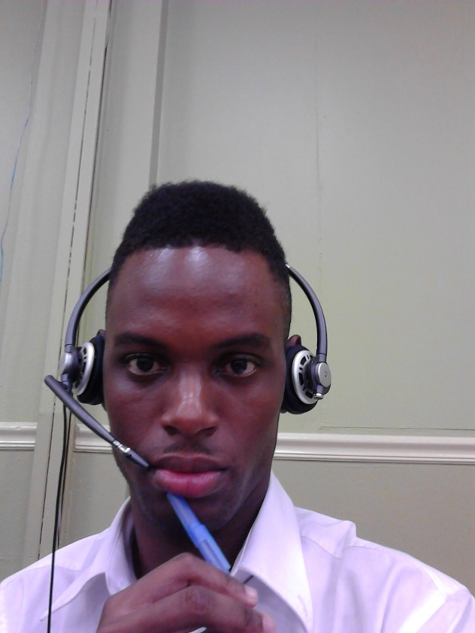

**LIME JAMAICA LIMITED, MANDEVILLE  
Card Sales Representative 2012-2014**

* Generated card sales of up to $150,000 per day.
* Awarded the Most Outstanding Sales Representative, 2013.
* Responded to customer queries with quality information and timeliness, based on strong product knowledge.

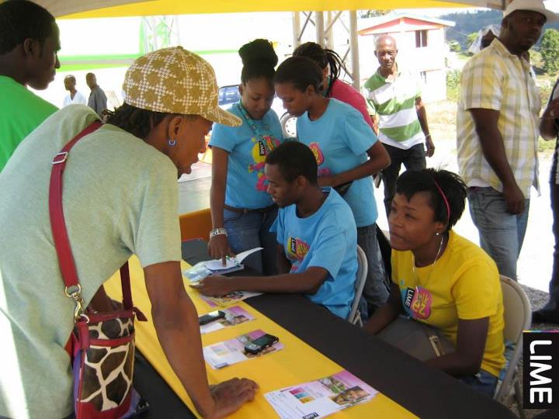

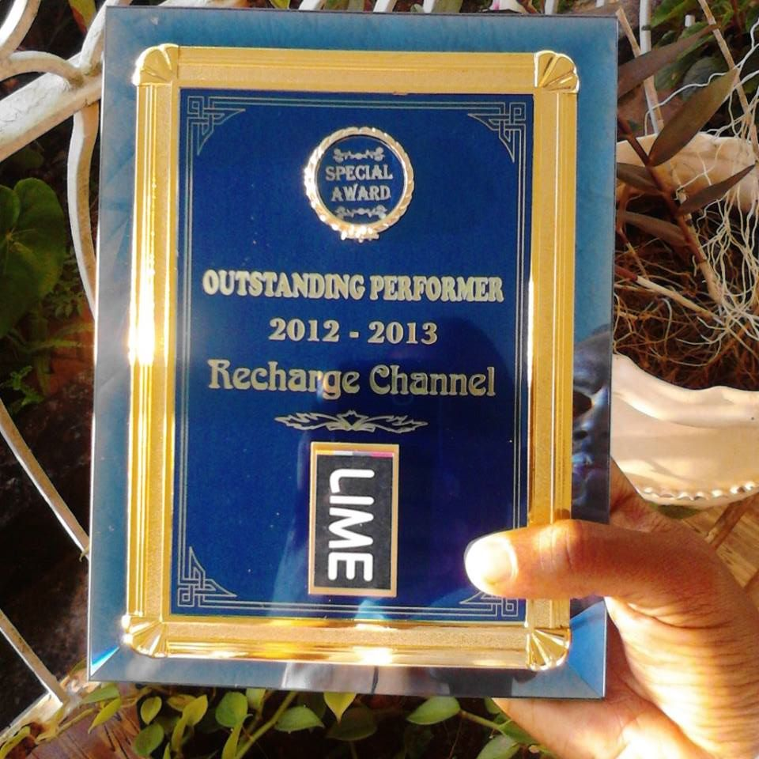

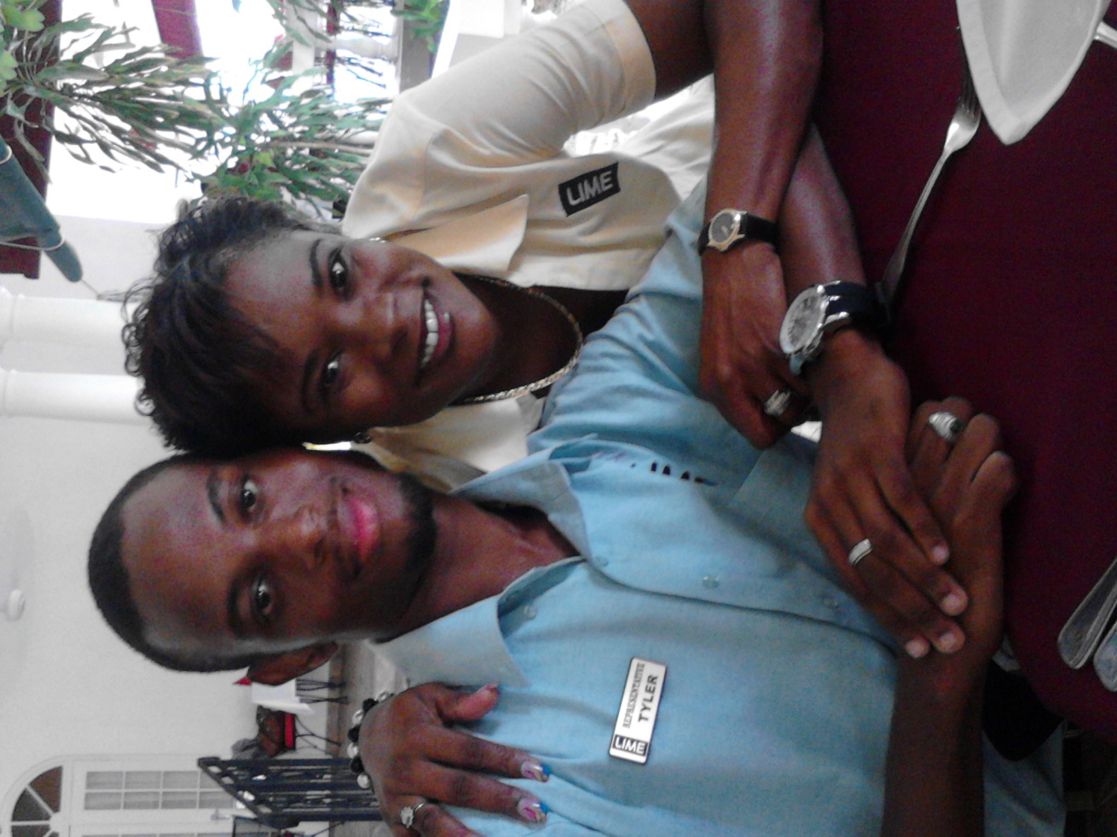

**PROGRESSIVE GROCERS, JAMAICA LIMITED (SHOPPERS FAIR)**

**Customer Services Representative and Frontend Staff Supervisor 2008-2011**

* Supervised the 50-member team of frontline staff.
* Enhanced the records management system including files and database to support station officers.

